|  |  |  |
| --- | --- | --- |
|  | **Rochester Institute of Technology**  **Golisano College of Computing and Information Sciences**  **School of Interactive Games and Media**  **2145 Golisano Hall – (585) 475-7680** |  |

**Data Structures & Algorithms for Games & Simulation II**

**IGME 309**

**Physics Solver**

This exercise follows lecture D14

1. Your code will generate a solution really similar to C14C like this:

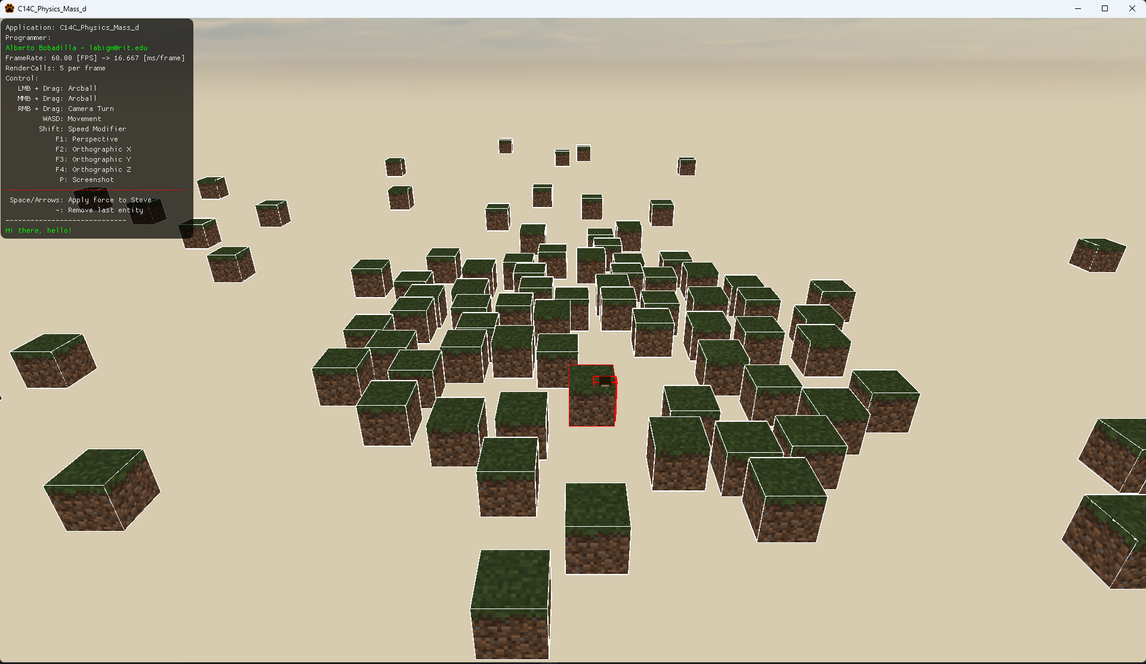

Steve pierces the cube and then once he reaches the base he separates, this is wrong.

1. This exercise will include the External Solver found in C14D
2. Your exercise is to fine-tune the values sent to the solver or modify the methods in the external solver so Steve does not pierce the cubes as he is falling and stay on top of them.
3. You may work in teams for this exercise but each student needs their individual solution.
4. Your submission will be only 3 files, SolverExt.h, SolverExt.cpp, AppClass.cpp please zip these files
   1. Note, not all the files might have been modified, this is based on the way you solve this exercise, even if you didn’t modify one or more of those files, please include them.